Name-Mridul

Enrollment N.o-03313702021

Set –A

1. Consider relational database:

Supplier (Supno, sname, supaddress)

Item (Itemno, Iname, stock)

Supp-Item (Supno, Itemno, rate)

Write RDBMS expression for the following

i. List all suppliers from ‘Varanasi’ city who supplies PISTON.

ii. Display all suppliers supply PISTON RINGS

iii. Change supplier names to upper case

Sol

Creating table

create table Supplier(Supno int(3) ,sname varchar(20),supaddress varchar(20));

create table Item(Itemno int(3) ,Iname varchar(20),Stock varchar(20));

create table Sup_Item(Supnno int(3) ,Itemno int(3),rate int(3));

Inserting Value

INSERT INTO Supplier Value( 10 , AB, 'Mumbai');

INSERT INTO Supplier Value( 11 , 'CD', 'Varnasi');

INSERT INTO Supplier Value( 12 , 'EF', 'Varnasi');

INSERT INTO Item Value( 50 , 'Piston', 'Varnasi');

INSERT INTO Item Value( 51 , 'Piston Rings', 'EF');

INSERT INTO Item Value( 52 , 'Piston Rings', 'GH');

INSERT INTO Sup_Item values( 10,50, 200);

INSERT INTO Sup_Item values( 11,52,120);

INSERT INTO Sup_Item values( 12,51, 300);

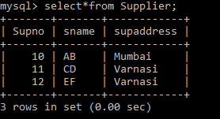

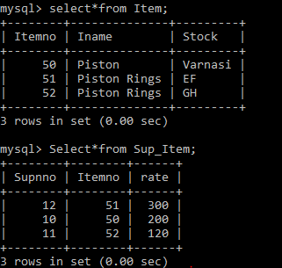

1. Select *from suppliers where supaddress=’varnasi’ in(select from item where itemname=piston);
2. Select*from suppliers in(select*from item where Iname=’Piston Rings’;
3. Select Upper(sname ) from supplier;

2. Implementation of DDL commands of SQL with suitable examples

i. Create table

ii. Alter table

iii. Drop Table

Sol

1. create table Supplier(Supno int(3) ,sname varchar(20),supaddress varchar(20));
2. ALTER TABLE Customers

ADD Email varchar(255);

1. Drop Table suppliers